Hive. Theory
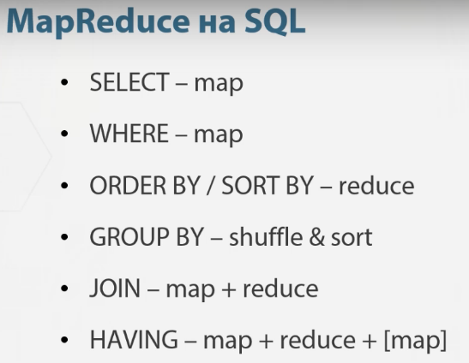

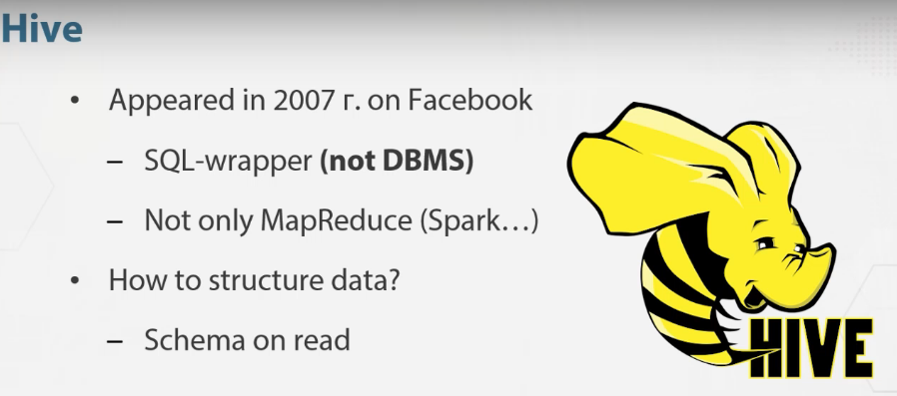

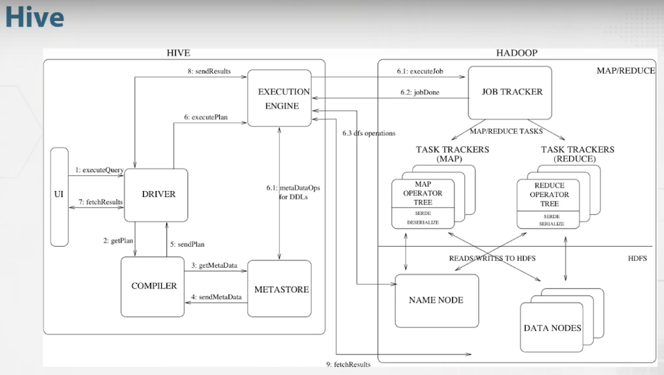
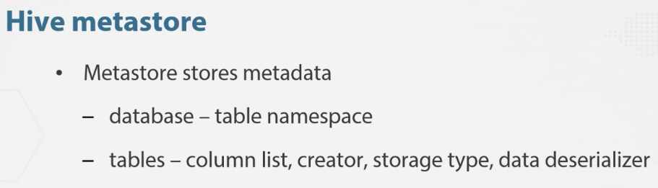
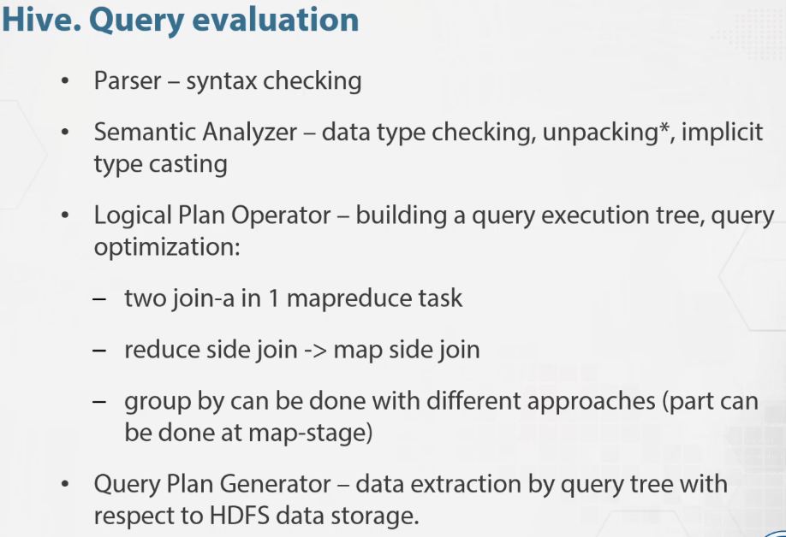

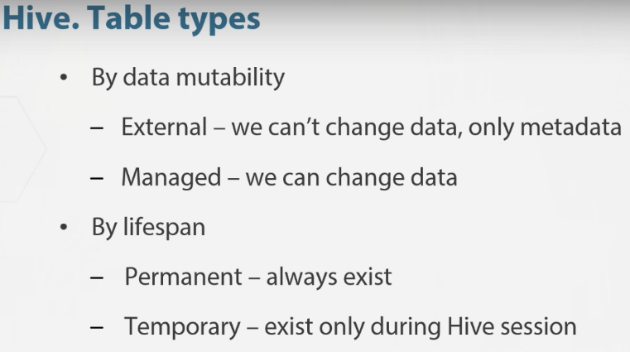

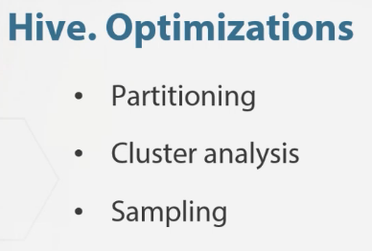

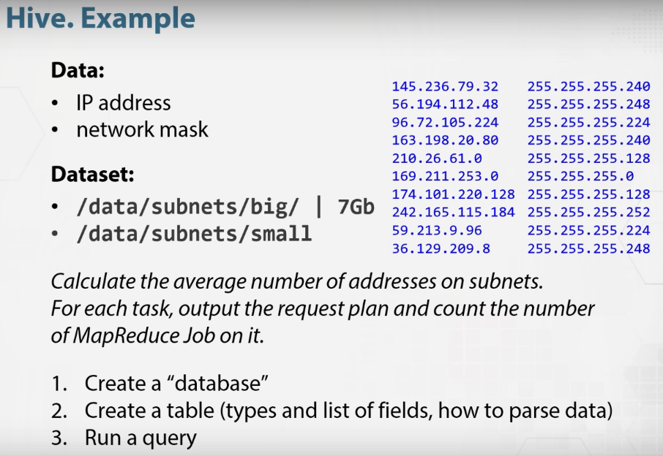
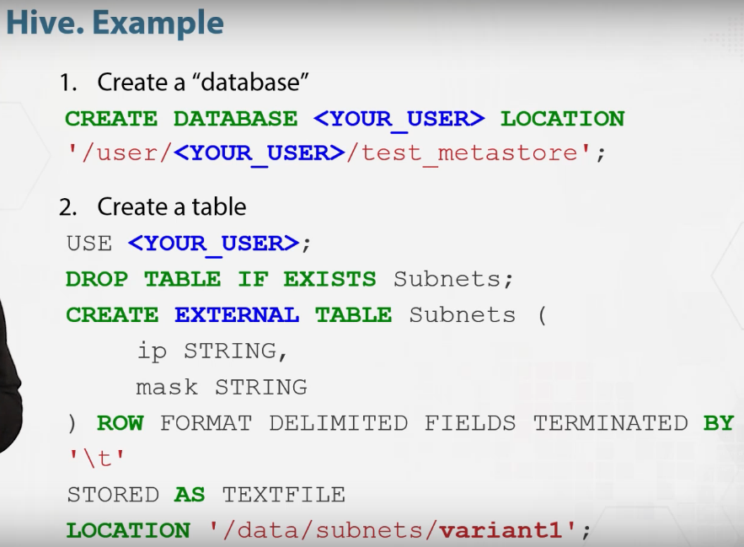
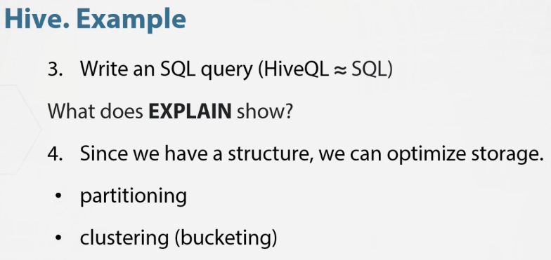

Hive. Practice
Variants to execute query:
FIRST VARIANT
Connect to Hadoop cluster via ssh
ssh <name>@hadoop2.yandex.ru
Start Hive session
hive
Write SQL
show databases;
Use Linux Shell command from Hive
!ls -l;

SECOND VARIANT
Or if we close Hive session we can do
hive -e 'show databases'
Specify the database which we will use
hive --database <name_of_database> -e 'show tables'

THIRD VARIANT
Create hql file and execute it
nano query.hql (или mcedit query.hql)
USE <name_of_database>;
SHOW TABLES;
hive -f query.hql

